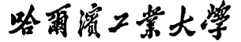


Report of Software Architecture

Homework 6.1-1: Legacy File Update Using OO Design Architecture

Basic information
Team name： _______________________________
Class number: ___________________________________________________
Department/school：
Team members with student numbers：

_______________________

Instructor’s comments and score
comments：

score：
signature of the instructor：

Year month date

- The objective of the program
  - input line by line all the contents from a text file
  - find all the words “republic of china” in each line and change the phrase into “taiwan”
  - sort all the lines according to the alphabetical order of the first character of the line
  - output all the contents to the output file
the design class diagram is as below
Input
PoliticalIssue
LegacyFileUpdateUI
-file: ArrayList
+update():void
-file: ArrayList
+update(): void
Sort
-file: ArrayList
+update ():void
Output
-file: ArrayList
+update(): void
<<interface>>
FileUpdateInterface
+update(); void

Figure 1 the deign class diagram

- How the program works?
Run the program LegacyFileUpdateUI, and a graphical user interface will appear. Then in you choose Sale1.txt, and click on button “process”, then the GUI will be as below.
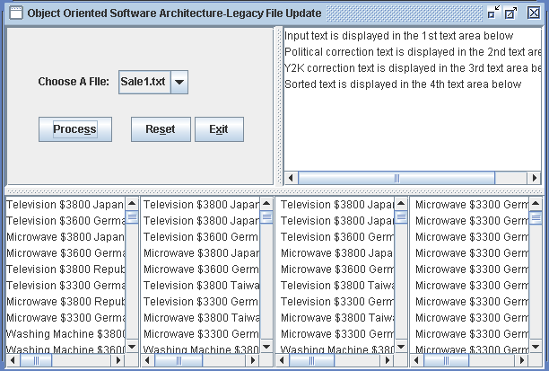

Figure 2. The GUI when running to process file Sale1.txt
The files such as Sale1.txt are the names of the actual .txt files, which can be put into the directory “TextFiles” by you.
After a user chooses a file name such as Sale1.txt, the LegacyFileUpdateUI creates object of class Input, and then calls its method update(), then all the contents of the Sale1.txt will be input into an arraylist data structure encapsulated by class Input and then the arrayList will be returned to the caller LegacyFileUpdateUI, which will display the contents to the first screen in the lower part of the screen. Then LegacyFileUpdateUI will create object of the class PoliticalIssue, and then calls its update() method, which will correct all the political issues and then will return the contents to the caller LegacyFileUpdateUI as done by the update() method in the Input class. The updated file is displayed onto the 2nd screen. The update() method in the class Sorting and Output will also be called in the same fashion.

3. Your task is as the following

Now, all the files
  - LegacyFileUpdateUI.java,
  - Input.java,
  - PoliticalIssue.java,
  - Sorting.java, and
  - Output.java
have all been implemented. You are required to
- Design a Java class called Y2KFixer.java in the same manner as the class PoliticalIssue to find every phrase “yy-mm-dd” that is used to express date in many programs in the 20th century in the file and change it into “19yy-mm-dd”;
- Add this newly designed class Y2KFixer to the class hierarchy;
- Then inside class LegacyFileUpdateUI.java, you need to create an object of Y2KFixer.java and then calls its update() method. This action will occur after the action PoliticalIssue and before the action Sorting.

Report:

- Describe your finished homework, including
  - What class has been added to the design class hierarchy in figure 1?
  - The relationship between the existing class FileUpdateInterface and the newly added class.

- Draw a flow chart to express the steps taken to fix the Y2K problems, which will be carried out by the update() method in the class Y2KFixer.

- Show the typical input and output from running your program, including every middle steps

